CENWP-ODJ 9/7/2023

MEMORANDUM FOR THE RECORD

SUBJECT: 23JDA36 Chinook Mort from SFL

On Thursday 7 September 2023, at approximately 0630, JDA fisheries personnel found a dead Chinook salmon on the sidewalk near the count station (see fig. 1). It was determined the fish had jumped out of the ladder from above and fell on the sidewalk. A fish was previously found in the same location in 2020 (see fig. 2)

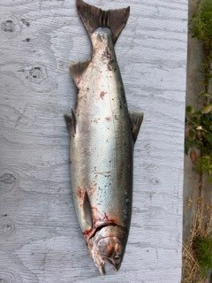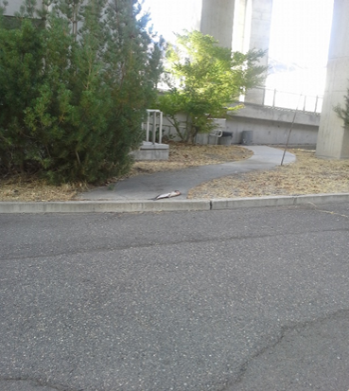
Figure 1 salmonoid mort from SFL Figure 2 Location of mort from 2020 (very close to location of mort in 2023)

- Species – Chinook
- Origin – clipped
- Length – ~34in
- Marks and tags – None
- Marks and Injuries found on carcass – None
- Cause and Time of Death – Fall from ladder
- Future and Preventative Measures – Fish jumping from the South ladder is a rare event (last occurred 8/31/20). JD fisheries will continue to monitor the area, and when the ladder is dewatered during the winter maintenance period JDF will look into the feasibility of netting over the area.

Sincerely,
JDA Project Fisheries

